**LAB#4**

**Advance JavaScript Concepts**

**OBJECTIVE:** Learn and Understand advanced JavaScript features and modern techniques.

# STUDENT TASK

**Task 1: Process Product Data.**

* **CODE**

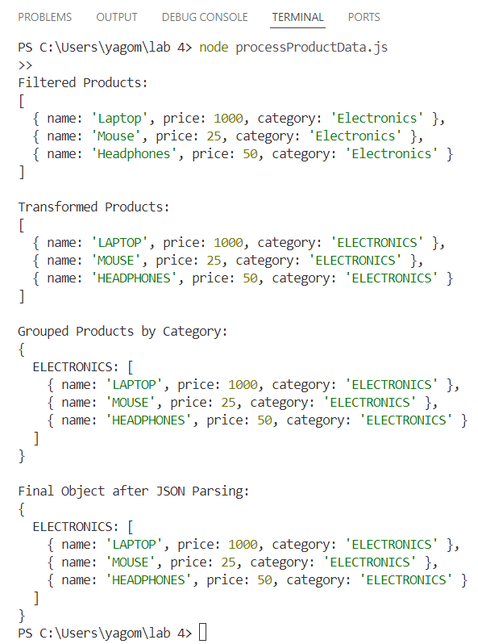

* **OUTPUT**

# HANDS ON PRACTICE TASK (CLASS PRACTICE)

**Task 1: Arrow Function Practice.**

* **CODE**

* **OUTPUT**

**Task 2: Array Destructuring Practice.**

* 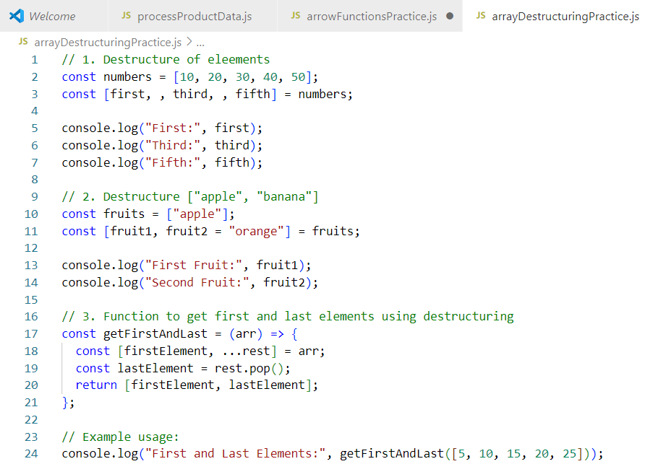**CODE**
* **OUTPUT**

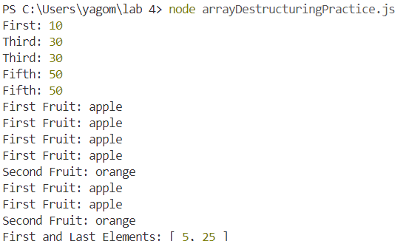

**Task 3: Hoisting Demonstration.**

* 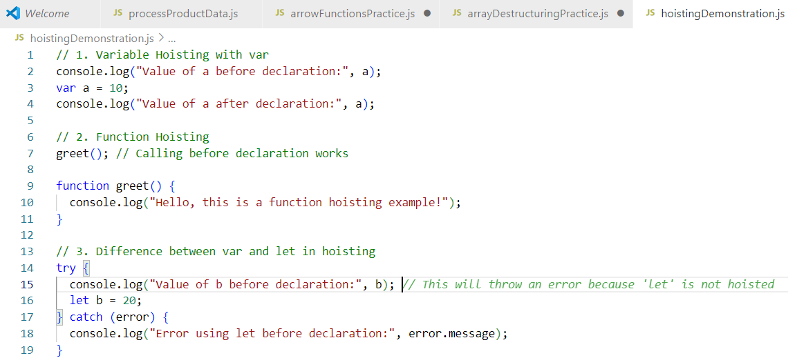**CODE**
* **OUTPUT**

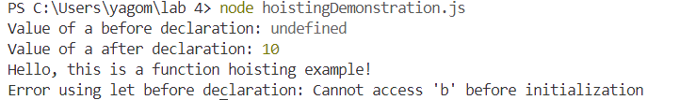

**Task 4: JSON Practice.**

* 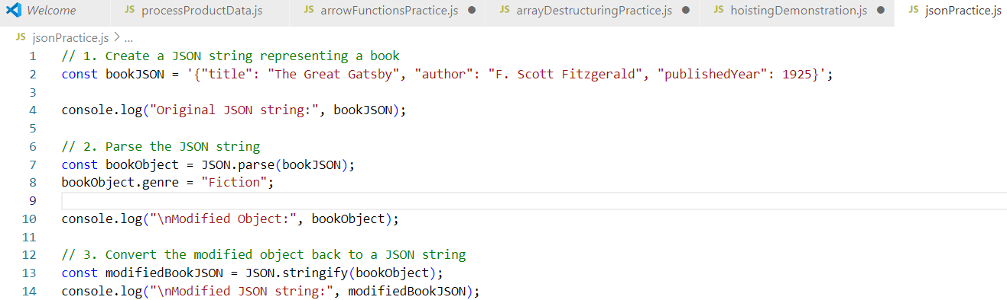**CODE**

* **OUTPUT**

